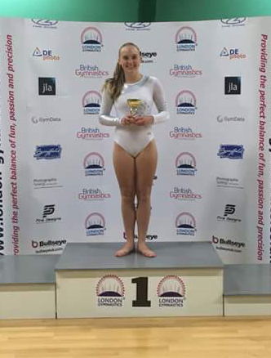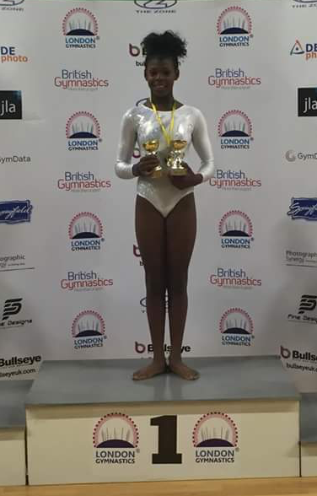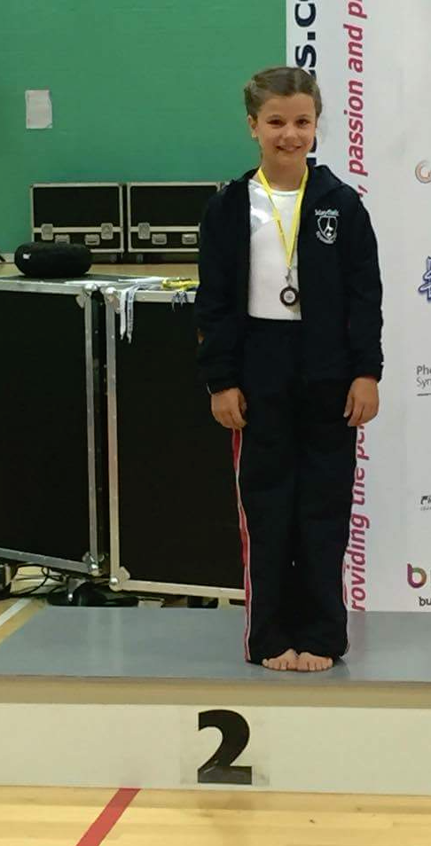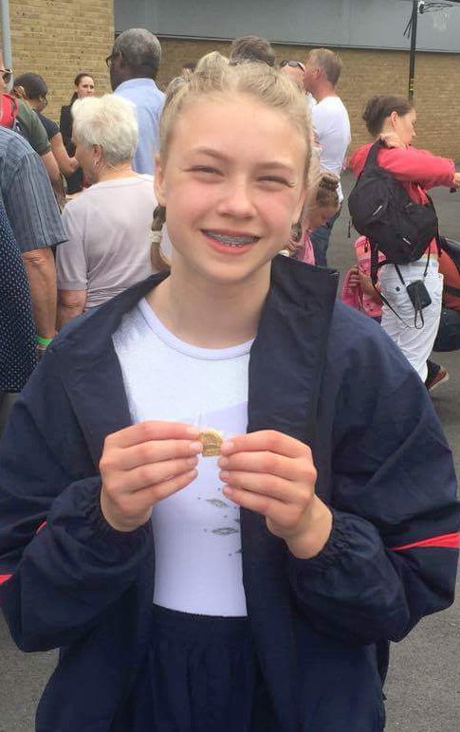 ­­­

Look out for information regarding our own Mayfield club competition in March 2017. All gymnasts at MGC can enter.

Keep your eyes peeled for the entry form so you do not miss out on this exciting event!

**Mayfield Gymnastics Club**

**Autumn 2016 Newsletter**

**Welcome back to all existing members and welcome to all new starters!**

**Important Notices**

* Please note classes continue during the half term week
* Please ensure all children have a drink and go to the toilet before their lesson. Gymnasts attending a one hour session will not be able to leave the gym during this time
* Please make sure your children are in correct gymnastics clothing before entering the gym. Girls must wear a leotard. No jewellery is allowed and long hair must be tied back
* Leotards are on sale at MGC – please ask at reception for more details
* Parking on site is £2 per day- If picking up/dropping off (10 mins) no payment is needed

**Competition corner**

Congratulations to the following gymnasts for representing Mayfield GC in the London Regional Championships July 2016

Saskia Wilkinson

Emily Ash

Rosa Edwards

Constance Lubbock

Coco Green

Josie Winnick

Paige Burke-Shaw - Gold medal winner

Madeleine Marshall -Silver medal winner

Georgia Velasco - Vault overall winner

Congratulations also to all MGC gymnasts who competed in our Annual Mayfield Gymnastics Competition in March 2016

**Dates for your diary**

**Term dates 🡪** 6th September – 17th December 2016

**Parents watching week 🡪** 10th - 17th December 2016

If you are unable to attend watching week we do have a live feed on the screen in the reception area which is viewable for all sessions daily

**Christmas party 🡪** 10th December 2016 3-5pm

Keep an eye out for booking forms later in the term

**London Regional Championships**

Inspired by the amazing achievements of the British Gymnastics Squad at the Rio Olympic games!